**USING RAPTOR –SWAP 2 NUMBERS**

**A.V BHargava(191911110)**

**FLOWCHART**

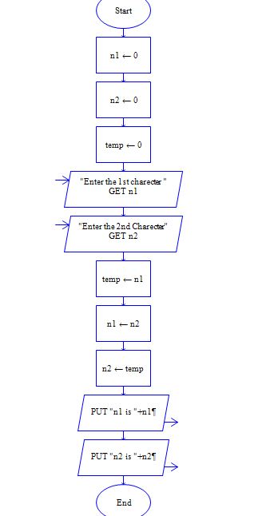

**INPUT**

N1 = 11

N2 = 25

**OUTPUT**

